Assessment Scoping Requirements for PA-DSS
ControlCase

ControlCase is an authorized vendor for providing PCI DSS & PA DSS certification services for USA, CEMEA and Asia-Pacific regions.
Introduction

ControlCase is a Virginia, USA based company that caters to the security and privacy and IT audit needs of companies in the North American, Middle East and Asia/Pacific markets. Our service offerings include IT audit services, IT consulting services and certification against industry standards.
About us

In order for us to finalize scope of assessment and submit a commercial proposal, we request you to complete and furnish us the following information in respect of application undergoing PA DSS certification environment.
Scoping Requirements

Company Details:

        - Software Vendor Name
Zion Corp.

        - Software Vendor Contact Information
Huynh Nguyen Ha Duy
Phan Canh Nhat

        - Software Vendor Mailing Address
duyhnh@vng.com.vn
nhatpc@vng.com.vn

Product Details:

        - Product Name
Standard Bank Interface (SBI)

        - Product Version
1.0

        - Detailed Description of the Payment Application/family of products.

Standard Bank Interface (SBI) provides a uniform technical interface so that bank development team can easily build secure services on top of the bank to provide standard APIs and payment service for all of their partners.

SBI can help bank:

- Offer a wider range of web and mobile apps to bank customers
- Reduce integration and maintenance costs for new applications
- Achieve better data control and security for the end-users,
- Control payment service quality

        - How the application is involved in Storing / processing or transmitting of Cardholder data (Card no., Expiry date, Cardholder name, Track data, CVV, PIN)?

- Storing truncated PAN (First 6 and Last 4)
- Transmitting and Processing: PAN, Expiry/Issuing date, Cardholder name, CVV, PIN/OTP

        - Is the application involved in authorization? Please briefly explain how?
- Yes: It provides authorization APIs for bank partners. However, It just receives cardholder information and transaction to forward to Corebank/CoreCard for authorization processing

        - Is the application involved in settlement? Please briefly explain how?
- Yeap: it provides transaction list for partner to do settlement. However, no cardholder information is provided in settlement API

        - Are selling/licensing this application to more than one customer?
- Yes, more than one customer

        - Do you have Resellers and/or Integrators for the product?
- Yes

        - Operating System supporting the Application. Also mention all other applications supporting the payment application.
RedHat Linux
CentOS Linux

        - Database Software supporting the payment application.

Oracle DB, MySQL DB

        - What programming language is the application written in?
Java

        - Please provide the approximate lines of code within the application.
70,000 lines of code

        - A network diagram of a typical implementation of the software (not necessarily a specific implementation at a merchant’s site) that includes, at high-level, connections into and out of a merchant’s network and the implementation components within the merchant’s network, including implementation of POS devices, systems, communication links, databases, and web servers as applicable.

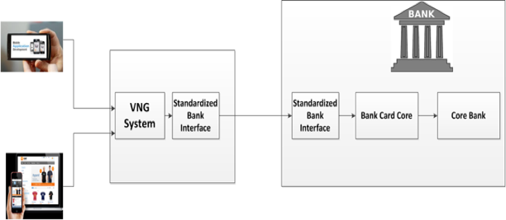
        - Mention payment application related software components, including third party software dependencies.
IBM MQ, Scribe, Pentaho, Jetty

        - Describe the typical entity that this product is sold to (for example, large, small, if industry-specific, Internet, brick-and-mortar) and vendor’s customer’s base. (e.g. market segment, big customer names).

Sold to banks

After you furnish this information, we will analyze the same and furnish you our proposal.

Mr. Suresh Dadlani
ControlCase,
203 Town Center
Andheri East
Mumbai 400025

www.controlcase.com
sdadlani@controlcase.com
Ph: +919820293399

